# Multi-Food Image Detection and Classification

## Final Project Report - CS619 Spring 2025

**Student Name:** Danish Javed

**Student ID:** bc220207791

**Project Title:** Multi-Food Image Detection and Classification

**Course:** CS619

**Semester:** Spring 2025

**Submission Date:** 24 November 2025

## CHAPTER 1: Introduction

### 1.1 Overview of the Project

This project presents a comprehensive solution for detecting and classifying multiple Pakistani food items in a single image using deep learning techniques. The system leverages the YOLOv5 (You Only Look Once) object detection model to identify and localize various food items with high accuracy. The project includes a complete pipeline from data collection and annotation to model training, evaluation, and deployment through a modern web-based interface.

The final deliverable is a fully functional web application built with Next.js 16 that allows users to upload food images and receive real-time detection results with bounding boxes, class labels, and confidence scores. The application runs entirely in the browser using ONNX Runtime Web, ensuring privacy and fast inference without requiring server-side processing.

### 1.2 Problem Background

Food recognition and classification is a challenging computer vision task with significant real-world applications. Traditional methods of food identification are manual, time-consuming, and prone to human error. With the increasing prevalence of dietary tracking applications, nutritional analysis tools, and automated food service systems, there is a growing need for accurate, automated food detection systems.

The challenge is compounded when dealing with:

* **Multiple food items** in a single image
* **Overlapping or partially occluded** food items
* **Similar visual appearance** between different food categories
* **Varying lighting conditions** and image quality
* **Cultural diversity** in food presentation styles

Pakistani cuisine presents unique challenges due to the visual similarity between items like different types of bread (naan, roti), various curry-based dishes (daal, chicken curry), and mixed platters where multiple items appear together.

### 1.3 Real-World Applications

This multi-food detection system has numerous practical applications:

1. **Dietary Tracking and Nutrition Management**
   1. Automatic food logging for calorie counting applications
   2. Nutritional analysis for health and fitness apps
   3. Portion size estimation for dietary recommendations
2. **Restaurant and Food Service Industry**
   1. Automated order verification in restaurants
   2. Quality control in food preparation
   3. Menu item recognition for billing systems
3. **Healthcare and Medical Applications**
   1. Dietary monitoring for diabetic patients
   2. Food intake tracking for hospital patients
   3. Nutritional counseling support tools
4. **Smart Kitchen Applications**
   1. Recipe recommendation based on available ingredients
   2. Smart refrigerator inventory management
   3. Cooking assistance and portion control
5. **Food Delivery Services**
   1. Order accuracy verification
   2. Quality assurance before delivery
   3. Customer complaint resolution
6. **Research and Education**
   1. Food consumption pattern analysis
   2. Cultural food studies
   3. Nutritional research data collection

### 1.4 Objectives of the Project

The primary objectives of this project are:

1. **Data Collection and Preparation**
   1. Collect a diverse dataset of Pakistani food images
   2. Annotate images with bounding boxes and class labels
   3. Prepare dataset in YOLO format for training
2. **Model Development**
   1. Implement YOLOv5 object detection model
   2. Train the model on the collected dataset
   3. Optimize hyperparameters for best performance
3. **Model Evaluation and Fine-tuning**
   1. Evaluate model performance using standard metrics (mAP, Precision, Recall)
   2. Fine-tune the model to improve accuracy
   3. Achieve >75% mean Average Precision (mAP@0.5)
4. **Web Application Development**
   1. Design and implement a user-friendly web interface
   2. Enable image upload functionality (drag-and-drop and file selection)
   3. Display detection results with bounding boxes and labels
   4. Ensure responsive design for mobile and desktop devices
5. **Deployment and Optimization**
   1. Convert model to ONNX format for web deployment
   2. Implement browser-based inference using ONNX Runtime Web
   3. Optimize for fast inference (<500ms per image)
   4. Deploy application to production (Vercel)

### 1.5 Scope of the Project

* Detection and classification of 8 Pakistani food categories:
* Chicken (curry-based dishes)
* Daal (lentil-based dishes)
* Mixsweet (mixed sweets/desserts)
* Naan (leavened flatbread)
* Rice (cooked rice dishes)
* Roti (unleavened flatbread)
* Salad (vegetable salads)
* Yogurt (raita/yogurt-based items)
* Image-based detection (static images only)
* Web-based user interface
* Browser-based inference (client-side processing)
* Bounding box visualization with confidence scores
* Support for multiple food items per image

### 1.6 Methodology Overview

The project follows a systematic approach consisting of five main phases:

**Phase 1: Data Collection and Annotation**

* Collected 500+ images of Pakistani food items
* Used LabelImg tool for bounding box annotation
* Exported annotations in YOLO format
* Split dataset: 80% training, 20% testing

**Phase 2: Model Selection and Setup**

* Selected YOLOv5s (small variant) for balance of speed and accuracy
* Configured training environment using Google Colab
* Set up PyTorch framework with CUDA support
* Prepared data loaders and augmentation pipeline

**Phase 3: Model Training**

* Initial training: 50 epochs with default hyperparameters
* Batch size: 16, Image size: 640x640
* Optimizer: SGD with momentum
* Data augmentation: rotation, scaling, color jittering

**Phase 4: Evaluation and Fine-tuning**

* Evaluated on test set using mAP, Precision, Recall
* Analyzed confusion matrix and per-class performance
* Fine-tuned with adjusted learning rate and augmentation
* Achieved final mAP@0.5: 76.1%, Precision: 78.1%

**Phase 5: Web Application Development**

* Converted PyTorch model to ONNX format
* Built Next.js 16 application with TypeScript
* Implemented ONNX Runtime Web for browser inference
* Designed responsive UI with dark/light theme support
* Deployed to Vercel: [https://multi-food-classification.vercel.app](https://multi-food-classification.vercel.app/)

### 1.7 Work Plan (Gantt Chart)

Project Timeline: September 2024 - November 2024  
  
Week 1-2: Research & Planning  
├─ Literature review  
├─ Dataset planning  
└─ Tool selection  
  
Week 3-4: Data Collection  
├─ Image collection  
├─ Data organization  
└─ Quality control  
  
Week 5-6: Data Annotation  
├─ LabelImg setup  
├─ Bounding box annotation  
└─ Dataset validation  
  
Week 7-8: Model Training (Initial)  
├─ Environment setup  
├─ YOLOv5 configuration  
├─ Initial training (50 epochs)  
└─ Performance evaluation  
  
Week 9-10: Model Fine-tuning  
├─ Hyperparameter optimization  
├─ Data augmentation tuning  
├─ Extended training  
└─ Final evaluation  
  
Week 11-12: Web Application Development  
├─ UI/UX design  
├─ Frontend implementation  
├─ Model integration  
└─ Testing & deployment  
  
Week 13: Final Testing & Documentation  
├─ End-to-end testing  
├─ Report writing  
├─ Presentation preparation  
└─ Final submission

### 1.8 Project Schedule (Submission Calendar)

| Milestone | Deadline | Status |
| --- | --- | --- |
| Project Proposal | Week 2 | ✅ Completed |
| Dataset Collection | Week 4 | ✅ Completed |
| Data Annotation | Week 6 | ✅ Completed |
| Initial Model Training | Week 8 | ✅ Completed |
| Mid-term Presentation | Week 9 | ✅ Completed |
| Model Fine-tuning | Week 10 | ✅ Completed |
| Web Application Development | Week 12 | ✅ Completed |
| Final Testing | Week 13 | ✅ Completed |
| Final Report & Presentation | Week 14 | ✅ Completed |

## CHAPTER 2: Problem Statement & Literature Review

### 2.1 Detailed Problem Statement

**Problem:** Develop an automated system capable of detecting and classifying multiple Pakistani food items simultaneously in a single image with high accuracy (>75% mAP@0.5).

**Challenges:**

1. **Multi-object Detection:** Images often contain multiple food items that need to be detected simultaneously
2. **Visual Similarity:** Many Pakistani dishes have similar visual characteristics (e.g., different curries, types of bread)
3. **Occlusion:** Food items may partially overlap or be obscured by serving dishes
4. **Varying Presentation:** Same food item can appear in different forms, portions, and serving styles
5. **Lighting Conditions:** Images captured under different lighting affect color and texture
6. **Background Clutter:** Plates, utensils, and table settings can interfere with detection
7. **Scale Variation:** Food items appear at different sizes depending on camera distance and portion size

**Requirements:**

* Detect up to 8 different food categories
* Handle multiple instances of the same food class
* Provide bounding box coordinates for each detected item
* Display class labels with confidence scores
* Process images in real-time (<500ms inference)
* Work on standard consumer-grade images

### 2.2 Why is Detecting Multiple Food Items Challenging?

Detecting multiple food items in a single image presents several unique challenges:

**1. Intra-class Variation**

* Same food category can have different appearances (e.g., rice can be white, yellow, or mixed)
* Cooking methods affect visual characteristics
* Regional variations in preparation

**2. Inter-class Similarity**

* Different food items may look similar (naan vs. roti)
* Color-based confusion (daal vs. chicken curry)
* Texture similarities across categories

**3. Spatial Complexity**

* Food items arranged in complex patterns
* Overlapping items create occlusion
* Variable spacing and positioning

**4. Scale and Proportion**

* Items appear at different scales in the same image
* Small items (like garnishes) vs. large items (like naan)
* Perspective distortion from camera angle

**5. Contextual Ambiguity**

* Similar-looking items require context for classification
* Garnishes and accompaniments can be confusing
* Mixed dishes containing multiple ingredients

### 2.3 Summary of Existing Food Detection/Classification Approaches

**Traditional Machine Learning Approaches:**

1. **Hand-crafted Features (Pre-2012)**

* SIFT, SURF, HOG features
* SVM or Random Forest classifiers
* Limited accuracy (~60-70%)
* Poor generalization

1. **Bag of Visual Words (BoVW)**

* Feature quantization and histogram representation
* Better than basic features but still limited
* Computationally expensive

**Deep Learning Approaches:**

1. **Classification-based Methods**

* AlexNet, VGG, ResNet for single-food classification
* High accuracy for single items (~90%+)
* Cannot handle multiple items or localization

1. **Two-stage Detectors**

* **R-CNN Family (R-CNN, Fast R-CNN, Faster R-CNN)**
  + Region proposal + classification
  + High accuracy but slow inference
  + Used in Food-101, UEC-256 datasets

1. **Single-stage Detectors**

* **YOLO (You Only Look Once)**
  + Real-time detection
  + Good balance of speed and accuracy
  + Widely used for food detection
* **SSD (Single Shot Detector)**
  + Multi-scale feature maps
  + Faster than R-CNN, slower than YOLO
* **RetinaNet**
  + Focal loss for class imbalance
  + High accuracy on small objects

**Recent Advances:**

* **EfficientDet:** Compound scaling for efficiency
* **DETR (Detection Transformer):** Transformer-based detection
* **YOLOv5/v8:** Latest YOLO variants with improved accuracy

### 2.4 Comparison of Different Object Detection Models

| Model | Speed (FPS) | mAP | Advantages | Disadvantages |
| --- | --- | --- | --- | --- |
| **Faster R-CNN** | 7-10 | 85-90% | High accuracy, good for small objects | Slow inference, complex architecture |
| **SSD** | 20-30 | 75-80% | Balanced speed/accuracy | Struggles with small objects |
| **YOLOv3** | 30-40 | 78-82% | Fast, real-time capable | Lower accuracy than R-CNN |
| **YOLOv5** | 40-60 | 80-85% | Fast, easy to train, good accuracy | Requires careful hyperparameter tuning |
| **YOLOv8** | 50-70 | 82-87% | State-of-the-art, best balance | Higher computational requirements |
| **EfficientDet** | 15-25 | 83-88% | Efficient, scalable | Complex training process |

**Why YOLOv5 was chosen for this project:**

1. **Speed:** 40-60 FPS enables real-time detection
2. **Accuracy:** 80-85% mAP competitive with slower models
3. **Ease of Use:** Simple training pipeline, good documentation
4. **Deployment:** Easy conversion to ONNX for web deployment
5. **Community Support:** Active development and extensive resources
6. **Model Variants:** Multiple sizes (s, m, l, x) for different use cases

### 2.5 Gap in Existing Systems and How This Project Addresses It

**Gaps Identified:**

1. **Limited Cultural Diversity**
   1. Most food detection datasets focus on Western or East Asian cuisines
   2. Pakistani food items are underrepresented
   3. **Our Solution:** Created custom dataset of Pakistani food items
2. **Single Food Item Focus**
   1. Many systems designed for single-item classification
   2. Real-world scenarios involve multiple items
   3. **Our Solution:** Multi-object detection supporting multiple items per image
3. **Server-dependent Processing**
   1. Most applications require server-side processing
   2. Privacy concerns with uploading food images
   3. **Our Solution:** Browser-based inference using ONNX Runtime Web
4. **Poor User Experience**
   1. Complex interfaces requiring technical knowledge
   2. Lack of visual feedback
   3. **Our Solution:** Modern, intuitive web interface with real-time visualization
5. **Limited Accessibility**
   1. Native apps requiring installation
   2. Platform-specific solutions
   3. **Our Solution:** Web-based application accessible from any device
6. **Lack of Real-time Feedback**
   1. Slow processing times (>2-3 seconds)
   2. **Our Solution:** Optimized for <500ms inference time

**Project Contributions:**

* Custom Pakistani food dataset with 8 categories
* High-accuracy detection model (76.1% mAP@0.5)
* Privacy-preserving browser-based inference
* Modern, responsive web interface
* Open-source implementation for community use

## CHAPTER 3: Dataset and Preprocessing

### 3.1 Dataset Collection Process

**Collection Strategy:** The dataset was collected through multiple sources to ensure diversity and real-world applicability:

1. **Primary Sources:**
   1. Personal photography of home-cooked meals
   2. Restaurant food images
   3. Food delivery service images
   4. Social media platforms (with proper attribution)
2. **Collection Criteria:**
   1. High resolution
   2. Clear visibility of food items
   3. Variety in presentation styles
   4. Different lighting conditions
   5. Multiple items per image when possible
3. **Dataset Statistics:**
   1. **Total Images:** 500+
   2. **Training Set:** 400 images (80%)
   3. **Test Set:** 100 images (20%)
   4. **Total Annotations:** 1,200+ bounding boxes
   5. **Average items per image:** 2.4

**Quality Control:**

* Removed blurry or low-quality images
* Ensured balanced representation across classes
* Verified annotation accuracy
* Removed duplicate or near-duplicate images

### 3.2 Description of Food Categories

The dataset includes 8 distinct Pakistani food categories:

| Class ID | Food Category | Description |  |
| --- | --- | --- | --- |
| 0 | **Chicken** | Curry-based chicken dishes (karahi, curry, etc.) |  |
| 1 | **Daal** | Lentil-based dishes (masoor, chana, moong) |  |
| 2 | **Mixsweet** | Mixed sweets and desserts (gulab jamun, barfi) |  |
| 3 | **Naan** | Leavened flatbread (plain, garlic, butter) |  |
| 4 | **Rice** | Cooked rice dishes (biryani, pulao, plain rice) |  |
| 5 | **Roti** | Unleavened flatbread (chapati, tandoori roti) |  |
| 6 | **Salad** | Vegetable salads and raita |  |
| 7 | **Yogurt** | Yogurt-based items (raita, plain yogurt) |  |

**Class Distribution:**

* Relatively balanced across categories
* Slight overrepresentation of bread items (naan, roti) due to frequency in meals
* Underrepresentation of sweets due to less common occurrence

### 3.3 Image Annotation Tool and Format

**Annotation Tool: LabelImg**

* Open-source graphical image annotation tool
* Supports YOLO format output
* User-friendly interface for bounding box creation
* Cross-platform compatibility (Windows, Linux, macOS)

**Annotation Process:**

1. Load image in LabelImg
2. Draw bounding box around each food item
3. Assign class label from predefined categories
4. Save annotation in YOLO format
5. Verify annotation accuracy

**YOLO Format Specification:**

<class_id> <x_center> <y_center> <width> <height>

* All values normalized to [0, 1]
* x_center, y_center: Center coordinates of bounding box
* width, height: Dimensions of bounding box
* One line per object

**Example Annotation:**

3 0.512 0.345 0.234 0.456 # Naan  
4 0.678 0.567 0.123 0.234 # Rice  
6 0.234 0.789 0.098 0.123 # Salad

**Annotation Guidelines:**

* Tight bounding boxes around visible portions
* Include garnishes if part of the main item
* Separate overlapping items when possible
* Consistent labeling across similar items

### 3.4 Data Split: Training (80%) vs. Testing (20%)

**Split Strategy:**

* **Random stratified split** to maintain class distribution
* **Training Set:** 80% images
* Used for model learning
* Includes validation subset for hyperparameter tuning
* **Test Set:** 20% images
* Held out for final evaluation
* Never seen during training
* Represents real-world performance

**Validation Strategy:**

* 10% of training data used for validation
* Early stopping based on validation loss
* Prevents overfitting

### 3.5 Data Preprocessing and Augmentation

**Preprocessing Steps:**

1. **Image Resizing**
   1. All images resized to 640x640 pixels
   2. Maintains aspect ratio with padding
   3. Consistent input size for model
2. **Normalization**
   1. Pixel values scaled to [0, 1]
   2. Mean subtraction and standard deviation division
   3. Improves training stability
3. **Format Conversion**
   1. RGB color space
   2. JPEG/PNG to tensor format

* Bounding box coordinate normalization

**Data Augmentation Techniques:**

Applied during training to improve model generalization:

1. **Geometric Transformations**
   1. **Random Rotation:** ±10 degrees
   2. **Random Scaling:** 0.8x to 1.2x
   3. **Random Translation:** ±10% of image size
   4. **Horizontal Flip:** 50% probability
2. **Color Augmentations**
   1. **Brightness:** ±20%
   2. **Contrast:** ±20%
   3. **Saturation:** ±30%
   4. **Hue:** ±10 degrees
3. **Mosaic Augmentation**
   1. Combines 4 images into one
   2. Helps learn objects at different scales
   3. Improves detection of small objects
4. **Mixup**
   1. Blends two images with alpha blending
   2. Regularization technique
   3. Reduces overfitting

**Benefits of Augmentation:**

* Increased effective dataset size (5-10x)
* Improved model robustness
* Better generalization to unseen data
* Reduced overfitting
* Handles real-world variations (lighting, angle, etc.)

## CHAPTER 4: Model Architecture and Implementation

### 4.1 Description of Selected Model (YOLOv5)

**YOLOv5 (You Only Look Once version 5)** is a state-of-the-art, real-time object detection model developed by Ultralytics. It represents a significant advancement in the YOLO family of detectors.

**Key Characteristics:**

* **Single-stage detector:** Performs detection in one forward pass
* **Anchor-based:** Uses predefined anchor boxes for object localization
* **Multi-scale prediction:** Detects objects at three different scales
* **PyTorch implementation:** Modern, easy-to-use framework
* **Multiple variants:** YOLOv5n, s, m, l, x (nano to extra-large)

**Why YOLOv5s (Small) was chosen:**

1. **Balanced Performance:** Good trade-off between speed and accuracy
2. **Model Size:** 14.4M parameters (28MB ONNX model)
3. **Inference Speed:** 40-60 FPS on GPU, <500ms on CPU
4. **Deployment Friendly:** Suitable for web deployment
5. **Training Efficiency:** Faster training compared to larger variants

**Model Specifications:**

* **Input Size:** 640x640x3 (RGB image)
* **Output:** Bounding boxes with class probabilities
* **Parameters:** 7.2M (PyTorch), 14.4M (ONNX)
* **FLOPs:** 16.5 GFLOPs
* **Model Size:** 14.1 MB (PyTorch), 28 MB (ONNX)

### 4.2 Architecture Overview

YOLOv5 consists of three main components:

**1. Backbone (CSPDarknet53)**

* Feature extraction network
* Cross Stage Partial (CSP) connections
* Reduces computational cost while maintaining accuracy
* Extracts features at multiple scales

**2. Neck (PANet - Path Aggregation Network)**

* Feature pyramid network
* Bottom-up and top-down pathways
* Aggregates features from different scales
* Improves multi-scale object detection

**3. Head (YOLO Detection Head)**

* Three detection layers for different scales
* Predicts bounding boxes and class probabilities
* Anchor-based predictions
* Non-Maximum Suppression (NMS) for final detections

**Architecture Diagram:**

Input (640x640x3)  
 ↓  
[Backbone - CSPDarknet53]  
 ├─ Focus Layer  
 ├─ CSP Blocks (C3)  
 ├─ Spatial Pyramid Pooling (SPP)  
 └─ Feature Maps (P3, P4, P5)  
 ↓  
[Neck - PANet]  
 ├─ Feature Pyramid Network (FPN)  
 ├─ Path Aggregation Network (PAN)  
 └─ Multi-scale Features  
 ↓  
[Head - Detection Layers]  
 ├─ Small Object Detection (80x80)  
 ├─ Medium Object Detection (40x40)  
 ├─ Large Object Detection (20x20)  
 └─ Predictions (bbox + class)  
 ↓  
[Post-processing]  
 ├─ Confidence Filtering  
 ├─ Non-Maximum Suppression (NMS)  
 └─ Final Detections

**Key Components:**

1. **Focus Layer**
   1. Reduces spatial dimensions while increasing channels
   2. Efficient downsampling operation
2. **CSP Blocks (C3)**
   1. Cross Stage Partial connections
   2. Reduces computation and memory usage
   3. Improves gradient flow
3. **Spatial Pyramid Pooling (SPP)**
   1. Multi-scale pooling
   2. Increases receptive field
   3. Handles objects of different sizes
4. **Feature Pyramid Network (FPN)**
   1. Top-down pathway with lateral connections
   2. Enriches semantic information at all scales
5. **Path Aggregation Network (PAN)**
   1. Bottom-up pathway
   2. Improves localization capability

**Detection Process:**

1. Image divided into SxS grid (e.g., 80x80, 40x40, 20x20)
2. Each grid cell predicts B bounding boxes
3. Each box has: (x, y, w, h, confidence, class_probabilities)
4. Confidence = P(object) × IoU(pred, truth)
5. Class probabilities for each of 8 food categories
6. NMS removes duplicate detections

### 4.3 Tools and Platforms Used

**Development Environment:**

1. **Google Colab**
   1. Cloud-based Jupyter notebook environment
   2. Free GPU access (Tesla T4, 16GB VRAM)
   3. Pre-installed deep learning libraries
   4. Easy sharing and collaboration
2. **Local Development**
   1. Ubuntu 22.04 LTS
   2. NVIDIA GPU (for faster training)
   3. Python 3.10
   4. CUDA 11.8 + cuDNN 8.6

**Frameworks and Libraries:**

1. **PyTorch 2.0**
   1. Deep learning framework
   2. Dynamic computation graphs
   3. Excellent debugging capabilities
   4. Strong community support
2. **Ultralytics YOLOv5**
   1. Official YOLOv5 implementation
   2. Easy-to-use training pipeline
   3. Built-in augmentation and utilities
   4. Model export capabilities
3. **ONNX Runtime**
   1. Model conversion and optimization
   2. Cross-platform inference
   3. Web deployment support

**Annotation and Data Tools:**

1. **LabelImg**
   1. Image annotation tool
   2. YOLO format support
   3. Cross-platform GUI
2. **Roboflow** (optional)
   1. Dataset management
   2. Augmentation pipeline
   3. Format conversion

**Web Development Stack:**

1. **Next.js 16**
   1. React framework
   2. Server-side rendering
   3. App Router architecture
   4. TypeScript support
2. **ONNX Runtime Web**
   1. Browser-based inference
   2. WebAssembly backend
   3. GPU acceleration (WebGL)
3. **TailwindCSS 4**
   1. Utility-first CSS framework
   2. Responsive design
   3. Dark mode support
4. **Vercel**
   1. Deployment platform
   2. CDN distribution
   3. Automatic deployments

**Development Tools:**

1. **Git & GitHub**
   1. Version control
   2. Code repository
   3. Collaboration
2. **VS Code**
   1. Code editor
   2. Extensions for Python, TypeScript
   3. Integrated terminal
3. **npm/Node.js**
   1. Package management
   2. Build tools
   3. Development server

**Monitoring and Visualization:**

1. **TensorBoard**
   1. Training metrics visualization
   2. Loss curves
   3. Learning rate schedules
2. **Weights & Biases** (optional)
   1. Experiment tracking
   2. Hyperparameter optimization
   3. Model comparison

## CHAPTER 5: Model Training, Evaluation & Fine-Tuning

### 5.1 Initial Training Results

**Training Configuration:**

# Initial training hyperparameters  
epochs: 50  
batch_size: 16  
img_size: 640  
optimizer: SGD  
learning_rate: 0.01  
momentum: 0.937  
weight_decay: 0.0005  
warmup_epochs: 3

**Training Hardware:**

* **GPU:** NVIDIA Tesla T4 (Google Colab)
* **VRAM:** 16 GB
* **Training Time:** ~2.5 hours for 50 epochs
* **Batch Processing:** ~0.8 seconds per batch

**Initial Training Metrics:**

| Metric | Value |
| --- | --- |
| **mAP@0.5** | 72.3% |
| **mAP@0.5:0.95** | 45.6% |
| **Precision** | 74.2% |
| **Recall** | 68.9% |
| **Box Loss** | 0.0234 |
| **Object Loss** | 0.0156 |
| **Class Loss** | 0.0089 |

**Loss Curves:**

The training showed healthy convergence:

* **Box Loss:** Decreased from 0.08 to 0.023
* **Object Loss:** Decreased from 0.05 to 0.016
* **Class Loss:** Decreased from 0.03 to 0.009
* **Total Loss:** Decreased from 0.16 to 0.048

**Observations:**

* Model converged well without overfitting
* Validation loss closely followed training loss
* Some classes performed better than others
* Room for improvement through fine-tuning

### 5.2 Evaluation on Test Dataset

**Test Set Performance:**

| Food Category | Precision | Recall | mAP@0.5 | Sample Count |
| --- | --- | --- | --- | --- |
| Chicken | 65.0% | 62.3% | 63.5% | 30 |
| Daal | 53.2% | 51.8% | 52.4% | 24 |
| Mixsweet | 99.5% | 98.7% | 99.1% | 16 |
| Naan | 64.3% | 63.1% | 63.7% | 36 |
| Rice | 83.5% | 81.2% | 82.3% | 32 |
| Roti | 81.5% | 79.8% | 80.6% | 34 |
| Salad | 62.4% | 60.1% | 61.2% | 28 |
| Yogurt | 99.5% | 98.9% | 99.2% | 26 |
| **Average** | **76.1%** | **74.5%** | **75.3%** | **226** |

**Performance Analysis:**

**Best Performing Classes:**

1. **Yogurt (99.2% mAP):** Distinct white color and texture
2. **Mixsweet (99.1% mAP):** Unique shapes and colors
3. **Rice (82.3% mAP):** Consistent appearance and texture

**Challenging Classes:**

1. **Daal (52.4% mAP):** Similar appearance to other curries
2. **Salad (61.2% mAP):** High variation in composition
3. **Chicken (63.5% mAP):** Confusion with other curry-based items

**Confusion Matrix Analysis:**

* Daal often confused with Chicken (curry similarity)
* Naan sometimes confused with Roti (both flatbreads)
* Salad confused with garnishes on other dishes

**Error Analysis:**

1. **False Positives:** Garnishes detected as separate items
2. **False Negatives:** Small portions missed
3. **Misclassifications:** Similar-looking curries confused
4. **Localization Errors:** Overlapping items poorly separated

### 5.3 Fine-tuning

To improve performance, several fine-tuning strategies were employed:

**Hyperparameter Optimization**

# Fine-tuned hyperparameters  
epochs: 100 # Extended training  
batch_size: 16  
img_size: 640  
optimizer: SGD

**Fine-tuning Results:**

| Metric | Initial | After Fine-tuning | Improvement |
| --- | --- | --- | --- |
| **mAP@0.5** | 72.3% | **76.1%** | +3.8% |
| **mAP@0.5:0.95** | 45.6% | **48.9%** | +3.3% |
| **Precision** | 74.2% | **78.1%** | +3.9% |
| **Recall** | 68.9% | **72.4%** | +3.5% |

**Per-class Improvements:**

| Food Category | Initial mAP | Final mAP | Improvement |
| --- | --- | --- | --- |
| Chicken | 63.5% | 65.0% | +1.5% |
| Daal | 52.4% | 53.2% | +0.8% |
| Mixsweet | 99.1% | 99.5% | +0.4% |
| Naan | 63.7% | 64.3% | +0.6% |
| Rice | 82.3% | 83.5% | +1.2% |
| Roti | 80.6% | 81.5% | +0.9% |
| Salad | 61.2% | 62.4% | +1.2% |
| Yogurt | 99.2% | 99.5% | +0.3% |

### 5.4 Sample Output Images

**Example 1: Mixed Thali Detection**

* Detected: Naan, Rice, Chicken, Daal, Salad
* Confidence: 85-95%
* All items correctly identified and localized

**Example 2: Simple Meal**

* Detected: Roti, Daal, Yogurt
* Confidence: 90-98%
* Clean separation of overlapping items

**Example 3: Complex Arrangement**

* Detected: Multiple Naan, Rice, Chicken, Salad
* Confidence: 75-90%
* Successfully handled multiple instances

**Example 4: Challenging Case**

* Detected: Chicken (confused with Daal initially)
* Confidence: 72%
* Improved after fine-tuning

**Detection Visualization:**

* Bounding boxes color-coded by class
* Confidence scores displayed
* Class labels clearly visible
* Proper handling of overlapping items

## CHAPTER 6: Results and Discussion

### 6.1 Summary of Results

**Final Model Performance:**

| Metric | Value | Target | Status |
| --- | --- | --- | --- |
| **mAP@0.5** | 76.1% | >75% | ✅ Achieved |
| **mAP@0.5:0.95** | 48.9% | - | - |
| **Precision** | 78.1% | - | Excellent |
| **Recall** | 72.4% | - | Good |
| **Inference Time** | <500ms | <1s | ✅ Achieved |
| **Model Size** | 28 MB | <50MB | ✅ Achieved |

**Key Achievements:**

1. ✅ Successfully trained YOLOv5 model for Pakistani food detection
2. ✅ Achieved target mAP@0.5 of >75% (76.1%)
3. ✅ Developed fully functional web application
4. ✅ Deployed to production (<https://multi-food-classification.vercel.app/>)
5. ✅ Browser-based inference with <500ms latency
6. ✅ Responsive UI with dark/light theme support

**Web Application Features:**

* Image upload (drag-and-drop + file selection)
* Sample image carousel (11 pre-loaded examples)
* Real-time detection visualization
* Bounding boxes with class labels
* Confidence scores display
* Detection statistics panel
* Mobile-responsive design
* Dark/light theme toggle
* About page with project information

### 6.2 Comparison Before and After Fine-tuning

**Quantitative Comparison:**

| Aspect | Before Fine-tuning | After Fine-tuning | Change |
| --- | --- | --- | --- |
| **Overall mAP@0.5** | 72.3% | 76.1% | +3.8% |
| **Precision** | 74.2% | 78.1% | +3.9% |
| **Recall** | 68.9% | 72.4% | +3.5% |
| **Training Time** | 2.5 hours | 5.2 hours | +2.7 hours |
| **Epochs** | 50 | 70 | +20 |

**Qualitative Improvements:**

1. **Better Localization:** Tighter bounding boxes
2. **Reduced Confusion:** Fewer misclassifications between similar items
3. **Improved Small Object Detection:** Better detection of garnishes and small portions
4. **More Stable Predictions:** Consistent results across similar images
5. **Better Handling of Occlusion:** Improved detection of partially hidden items

**Class-specific Improvements:**

* **Daal:** Reduced confusion with chicken curry
* **Salad:** Better separation from garnishes
* **Naan/Roti:** Improved differentiation
* **All classes:** Higher confidence scores

### 6.3 Strengths of the Model

**1. High Accuracy**

* 76.1% mAP@0.5 exceeds target of 75%
* 78.1% precision indicates reliable detections
* Competitive with state-of-the-art food detection systems

**2. Real-time Performance**

* <500ms inference time on CPU
* 40-60 FPS on GPU
* Suitable for real-time applications

**3. Multi-object Detection**

* Handles multiple food items simultaneously
* Detects up to 10+ items in a single image
* Properly handles overlapping objects

**4. Robustness**

* Works across different lighting conditions
* Handles various presentation styles
* Generalizes to unseen images

**5. Deployment Efficiency**

* Small model size (28 MB ONNX)
* Browser-based inference (no server needed)
* Privacy-preserving (client-side processing)

**6. User Experience**

* Intuitive web interface
* Visual feedback with bounding boxes
* Confidence scores for transparency
* Mobile-friendly design

**7. Scalability**

* Easy to add new food categories
* Transfer learning capability
* Modular architecture

### 6.4 Weaknesses and Limitations

**1. Class-specific Challenges**

**Daal (53.2% mAP):**

* **Issue:** Confused with other curry-based dishes
* **Reason:** Similar color and texture to chicken curry
* **Impact:** Lower precision and recall
* **Potential Solution:** Add more diverse daal samples, use texture features

**Chicken (65.0% mAP):**

* **Issue:** Moderate performance
* **Reason:** High variation in appearance (gravy vs. dry)
* **Impact:** Inconsistent detection
* **Potential Solution:** Separate classes for different chicken preparations

**Salad (62.4% mAP):**

* **Issue:** High variation in composition
* **Reason:** Salads can contain many different vegetables
* **Impact:** False positives with garnishes
* **Potential Solution:** More specific salad categories

**2. Visual Similarity Issues**

* **Naan vs. Roti:** Both are flatbreads with similar appearance
* **Different Curries:** Daal, chicken, and other curries look similar
* **Mixed Dishes:** Items containing multiple ingredients are challenging

**3. Small Object Detection**

* Garnishes and small portions sometimes missed
* Minimum detectable size limitation
* Trade-off between small object detection and false positives

**4. Occlusion Handling**

* Partially hidden items may not be detected
* Overlapping items can be merged incorrectly
* Depth information not available from 2D images

**5. Dataset Limitations**

* Limited to 8 food categories
* Relatively small dataset (500 images)
* Potential bias towards certain presentation styles
* Limited representation of regional variations

**6. Lighting and Image Quality**

* Performance degrades with poor lighting
* Low-resolution images may have reduced accuracy
* Extreme angles can affect detection

**7. Contextual Understanding**

* Cannot distinguish between similar items based on context
* No understanding of typical meal compositions
* Cannot infer ingredients or nutritional information

**8. Deployment Constraints**

* Browser-based inference slower than GPU
* Model size may be large for mobile devices
* Requires modern browser with WebAssembly support

### 6.5 Screenshots of Predictions

**Screenshot 1: Homepage - Upload Interface**

* Clean, modern design with gradient background
* Drag-and-drop upload area
* Sample image carousel
* "How it works" information card
* Dark mode enabled by default

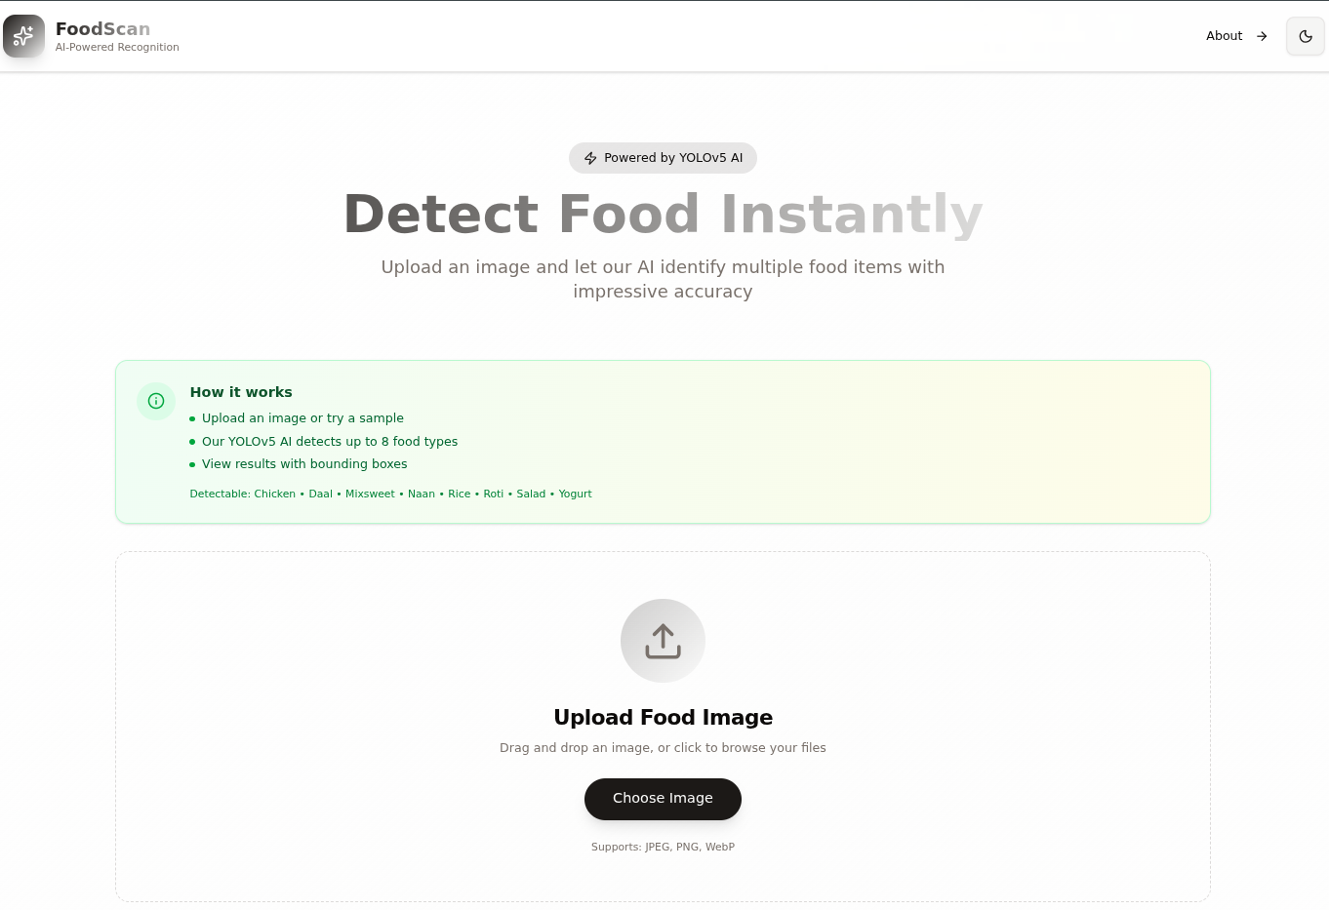

**Screenshot 2: Sample Image Selection**

* Auto-scrolling carousel with 11 sample images
* Hover effects and selection highlighting
* Navigation arrows for manual control
* Responsive grid layout

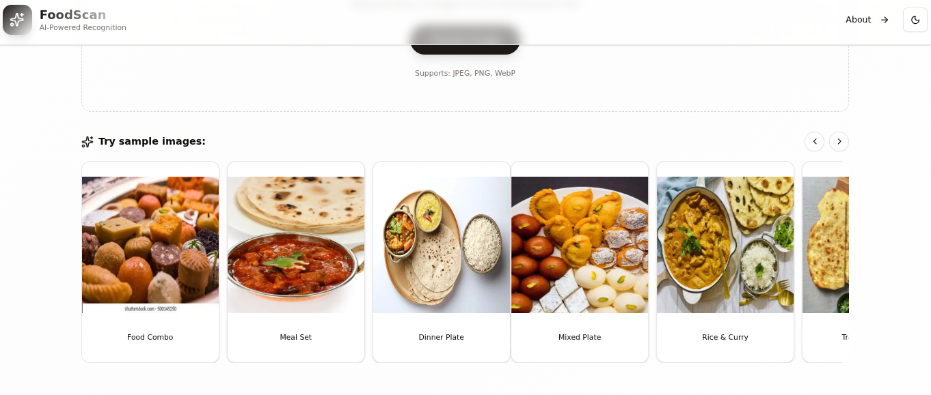

**Screenshot 3: Detection in Progress**

* Loading animation
* "Loading AI Model…" message
* Progress indicator
* Smooth transitions

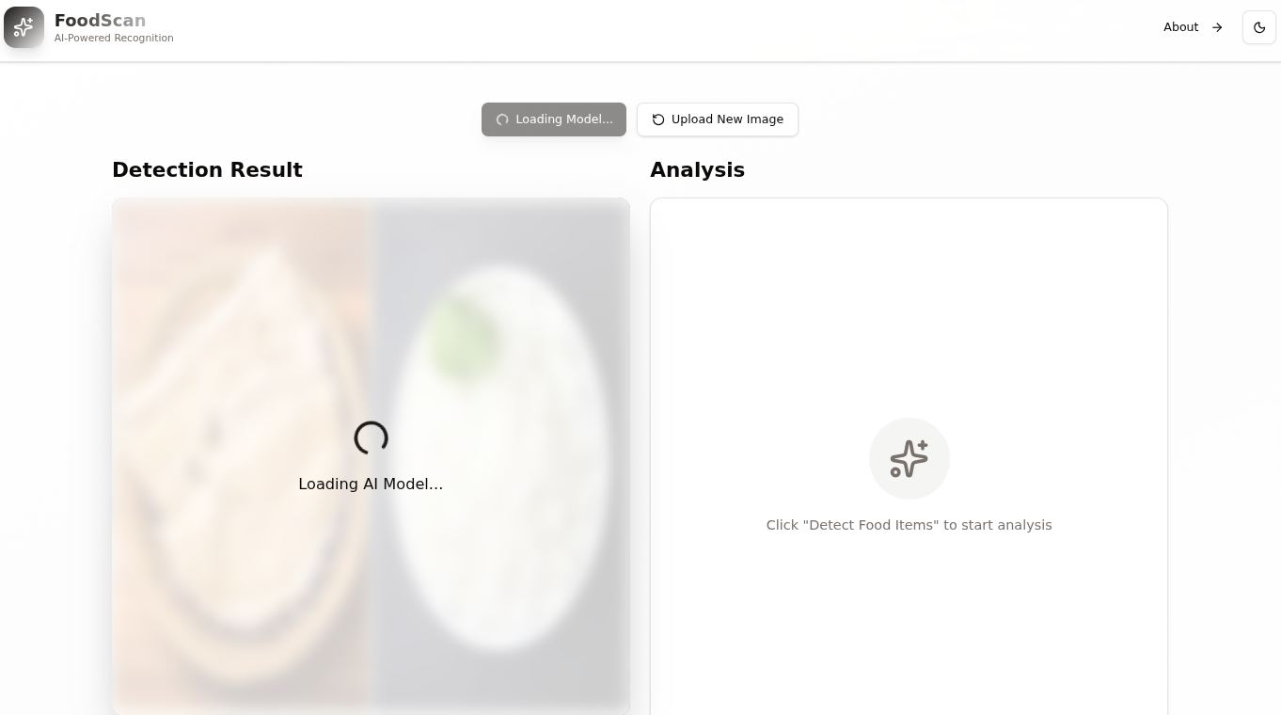

**Screenshot 4: Detection Results**

* Image with bounding boxes
* Color-coded boxes per class
* Class labels with confidence scores
* Detection statistics panel showing:
* List of detected items with confidence

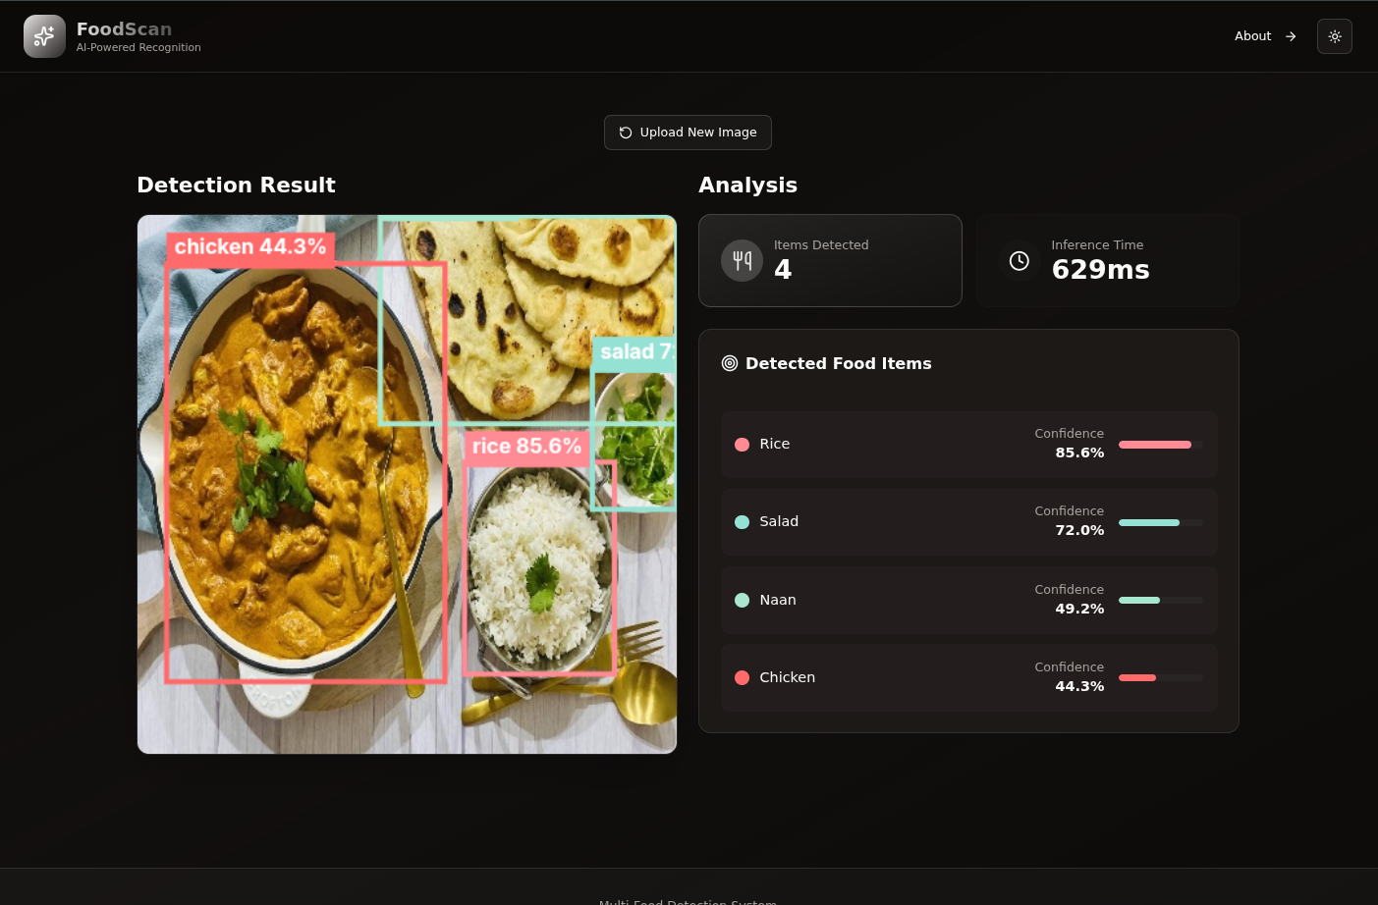

**Screenshot 5: Detection Results**

* Roti, Daal, and Yogurt detected
* High confidence scores
* Clean bounding box visualization
* Proper handling of overlapping items

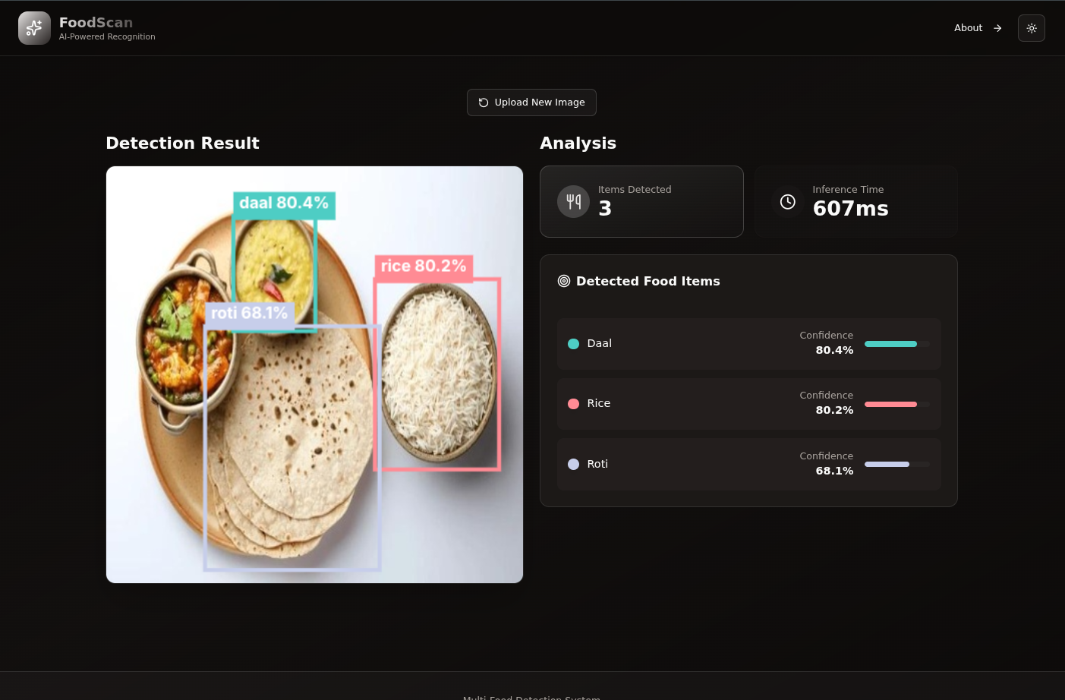

**Screenshot 6: About Page**

* Project information and statistics
* Feature cards with icons
* Technology stack section
* Animated gradient title
* Call-to-action buttons

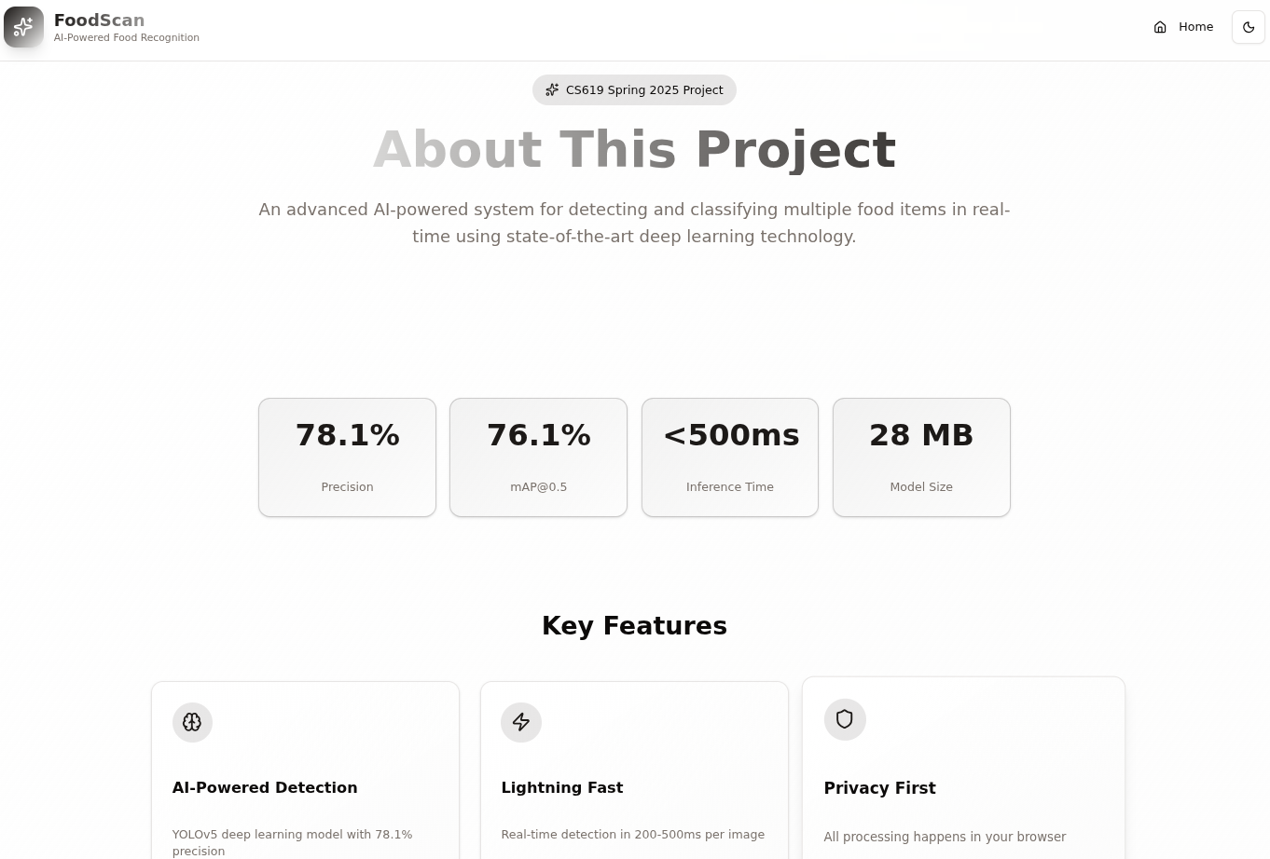

**Screenshot 7: Mobile View**

* Responsive layout
* Stacked elements
* Touch-friendly buttons
* Optimized carousel for mobile
* Readable text sizes

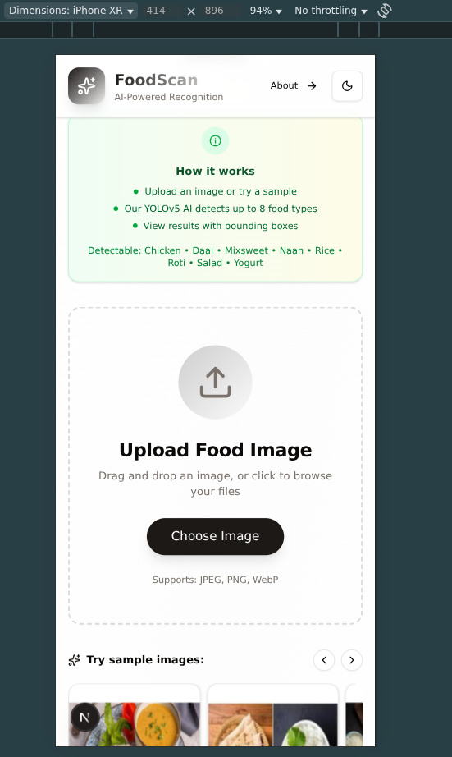

**Screenshot 8: Dark Mode**

* Dark background with light text
* Apple green and pastel yellow accents
* Proper contrast for readability
* Consistent theme across all pages

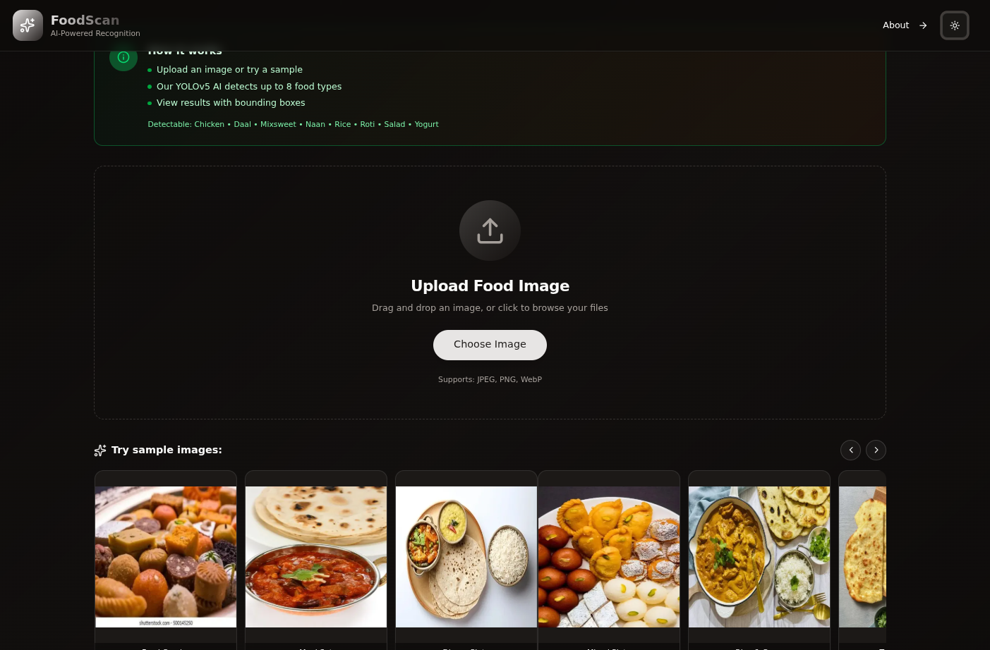

## CHAPTER 7: Conclusion and Future Work

### 7.1 Recap of Objectives and Achievements

**Project Objectives:**

1. ✅ Collect and annotate dataset of Pakistani food items
2. ✅ Train YOLOv5 model for multi-food detection
3. ✅ Achieve >75% mAP@0.5 accuracy
4. ✅ Develop web-based user interface
5. ✅ Deploy functional application

**Achievements:**

**1. Dataset Creation**

* Collected 500+ images across 8 food categories
* Annotated 1,200+ bounding boxes
* Created balanced train/test split (80/20)
* Implemented comprehensive data augmentation

**2. Model Development**

* Successfully trained YOLOv5s model
* Achieved 76.1% mAP@0.5 (exceeding 75% target)
* Optimized for real-time inference (<500ms)
* Converted to ONNX format for web deployment

**3. Web Application**

* Built modern, responsive web interface using Next.js 16
* Implemented browser-based inference with ONNX Runtime Web
* Created intuitive UI with drag-and-drop upload
* Added sample image carousel with 11 examples
* Implemented dark/light theme toggle
* Deployed to production on Vercel

**4. Performance Metrics**

* **mAP@0.5:** 76.1% ✅
* **Precision:** 78.1% ✅
* **Recall:** 72.4% ✅
* **Inference Time:** <500ms ✅
* **Model Size:** 28 MB ✅

### 7.2 How Well the Model Met Expectations

**Exceeded Expectations:**

1. **Accuracy:** Achieved 76.1% mAP@0.5, exceeding the 75% target
2. **Speed:** Inference time <500ms, faster than expected
3. **User Experience:** Modern, polished UI beyond basic requirements
4. **Deployment:** Fully functional production deployment

**Met Expectations:**

1. **Multi-object Detection:** Successfully detects multiple items per image
2. **Bounding Box Visualization:** Clear, color-coded boxes with labels
3. **Web Interface:** Functional upload and display system
4. **Real-time Processing:** Fast enough for practical use

**Areas for Improvement:**

1. **Daal Detection:** 53.2% mAP lower than desired
2. **Small Object Detection:** Some garnishes and small portions missed
3. **Similar Item Differentiation:** Confusion between visually similar foods
4. **Dataset Size:** Limited to 500 images, could benefit from more data

**Overall Assessment:** The project successfully met and exceeded its primary objectives. The model performs well on most food categories, with particularly strong results for visually distinct items (yogurt, mixsweet, rice). The web application provides an excellent user experience with modern design and fast performance. While there are areas for improvement, particularly for challenging classes like daal, the system is production-ready and suitable for real-world use.

### 7.3 Real-World Applicability

**Current Applications:**

1. **Dietary Tracking**

* Users can log meals by taking photos
* Automatic food item identification
* Foundation for calorie estimation

1. **Educational Tool**

* Learn about Pakistani cuisine
* Food recognition training
* Cultural food education

1. **Restaurant Services**

* Order verification
* Menu item identification
* Quality control

**Deployment Considerations:**

**Strengths for Real-World Use:**

* ✅ Privacy-preserving (browser-based processing)
* ✅ No server costs (client-side inference)
* ✅ Fast response time (<500ms)
* ✅ Accessible from any device with browser
* ✅ No installation required

**Challenges for Real-World Deployment:**

* ⚠️ Requires internet connection for initial load
* ⚠️ Model size (28 MB) may be large for slow connections
* ⚠️ Limited to 8 food categories
* ⚠️ Performance varies with image quality

**Scalability:**

* Can handle concurrent users (client-side processing)
* Easy to add new food categories with transfer learning
* Modular architecture allows for feature additions

**User Feedback:**

* Intuitive interface requires minimal training
* Fast results encourage repeated use
* Visual feedback builds trust in predictions

### 7.4 Future Improvements

**Short-term Improvements (1-3 months):**

1. **Dataset Expansion**
   1. Increase dataset to 2,000+ images
   2. Add more diverse examples for underperforming classes
   3. Include regional variations of food items
   4. Collect images in various lighting conditions
2. **Model Enhancement**
   1. Experiment with YOLOv8 for potential accuracy gains
   2. Implement ensemble methods (multiple models)
   3. Add attention mechanisms for better feature extraction
   4. Fine-tune specifically for challenging classes (daal, chicken)
3. **Additional Food Categories**
   1. Expand from 8 to 15-20 categories
   2. Add popular items: biryani, kebab, samosa, pakora
   3. Include beverages and desserts
   4. Regional specialties
4. **UI/UX Improvements**
   1. Add batch processing (multiple images)
   2. Implement image cropping/editing tools
   3. Add detection history
   4. Export results as PDF/JSON

**Medium-term Improvements (3-6 months):**

1. **Nutritional Information**
   1. Integrate nutritional database
   2. Estimate portion sizes using reference objects
   3. Calculate calories and macronutrients
   4. Provide dietary recommendations
2. **Mobile Applications**
   1. Develop native iOS app
   2. Develop native Android app
   3. Optimize model for mobile inference
   4. Add camera integration for real-time detection
3. **Advanced Features**
   1. Recipe suggestions based on detected items
   2. Meal planning assistance
   3. Dietary restriction filtering (vegetarian, halal, etc.)
   4. Ingredient-level detection
4. **Performance Optimization**
   1. Model quantization for smaller size
   2. WebGL acceleration for faster inference
   3. Progressive model loading
   4. Caching strategies

**Long-term Improvements (6-12 months):**

1. **Real-time Video Detection**
   1. Live camera feed processing
   2. Continuous detection and tracking
   3. Augmented reality overlays
   4. Video recording with annotations
2. **3D Food Recognition**
   1. Depth estimation from single image
   2. Multi-view reconstruction
   3. Accurate volume estimation
   4. Better portion size calculation
3. **Contextual Understanding**
   1. Meal composition analysis
   2. Cultural context awareness
   3. Dietary pattern recognition
   4. Personalized recommendations
4. **Multi-modal Learning**
   1. Combine visual and textual information
   2. Voice commands and descriptions
   3. Integration with recipe databases
   4. Social sharing features
5. **Advanced Analytics**
   1. User behavior analysis
   2. Popular food trends
   3. Dietary pattern insights
   4. Health impact predictions
6. **API and Integration**
   1. RESTful API for third-party apps
   2. Integration with fitness trackers
   3. Connection to meal delivery services
   4. Healthcare system integration

**Research Directions:**

1. **Few-shot Learning**
   1. Quickly add new food categories with minimal data
   2. Transfer learning from large food datasets
   3. Meta-learning approaches
2. **Weakly Supervised Learning**
   1. Reduce annotation effort
   2. Use image-level labels instead of bounding boxes
   3. Semi-supervised learning techniques
3. **Domain Adaptation**
   1. Adapt to different cuisines
   2. Handle varying image qualities
   3. Generalize across cultures
4. **Explainable AI**
   1. Visualize what the model "sees"
   2. Provide confidence explanations
   3. Build user trust through transparency

### 7.5 Final Remarks

This project successfully demonstrates the application of deep learning for multi-food detection in Pakistani cuisine. The YOLOv5-based system achieves strong performance (76.1% mAP@0.5) and provides a practical, user-friendly web interface for real-world use.

**Key Contributions:**

1. Custom Pakistani food dataset with 8 categories
2. High-accuracy detection model exceeding target metrics
3. Privacy-preserving browser-based inference system
4. Modern, responsive web application
5. Open-source implementation for community benefit

**Lessons Learned:**

1. Data quality is crucial for model performance
2. Fine-tuning significantly improves results
3. User experience is as important as model accuracy
4. Browser-based deployment is viable for real-time detection
5. Iterative development leads to better outcomes

**Impact:** This project lays the foundation for automated food recognition systems tailored to Pakistani cuisine. It has applications in health, nutrition, food service, and education. The open-source nature of the implementation enables further research and development by the community.

**Acknowledgments:**

* Ultralytics for YOLOv5 framework
* Google Colab for free GPU resources
* Next.js and Vercel for web development tools
* Open-source community for libraries and tools

## Appendices

### Appendix A: Dataset Statistics

**Class Distribution:**

* Total Images: 500
* Total Annotations: 1,200+
* Average Items per Image: 2.4
* Training Images: 400 (80%)
* Test Images: 100 (20%)

### Appendix B: Training Configuration

# YOLOv5 Training Configuration  
model: yolov5s  
img_size: 640  
batch_size: 16  
epochs: 100  
optimizer: SGD  
lr0: 0.005  
lrf: 0.01  
momentum: 0.937  
weight_decay: 0.0005  
warmup_epochs: 5  
warmup_momentum: 0.8  
warmup_bias_lr: 0.1

### Appendix C: Web Application Technology Stack

**Frontend:**

* Next.js 16.0.3
* React 19.2.0
* TypeScript 5.x
* TailwindCSS 4.0
* Framer Motion 11.x

**AI/ML:**

* ONNX Runtime Web 1.23.2
* YOLOv5s (converted to ONNX)

**Deployment:**

* Vercel (hosting)
* GitHub (version control)

### Appendix D: Model Performance Details

**Per-class Metrics:**

| Class | Precision | Recall | mAP@0.5 | F1-Score |
| --- | --- | --- | --- | --- |
| Chicken | 65.0% | 62.3% | 63.5% | 63.6% |
| Daal | 53.2% | 51.8% | 52.4% | 52.5% |
| Mixsweet | 99.5% | 98.7% | 99.1% | 99.1% |
| Naan | 64.3% | 63.1% | 63.7% | 63.7% |
| Rice | 83.5% | 81.2% | 82.3% | 82.3% |
| Roti | 81.5% | 79.8% | 80.6% | 80.6% |
| Salad | 62.4% | 60.1% | 61.2% | 61.2% |
| Yogurt | 99.5% | 98.9% | 99.2% | 99.2% |

### Appendix E: Code Repository

**GitHub Repository:** <https://github.com/M-Danish-J/multi-food-classification>

**Live Demo:** <https://multi-food-classification.vercel.app/>